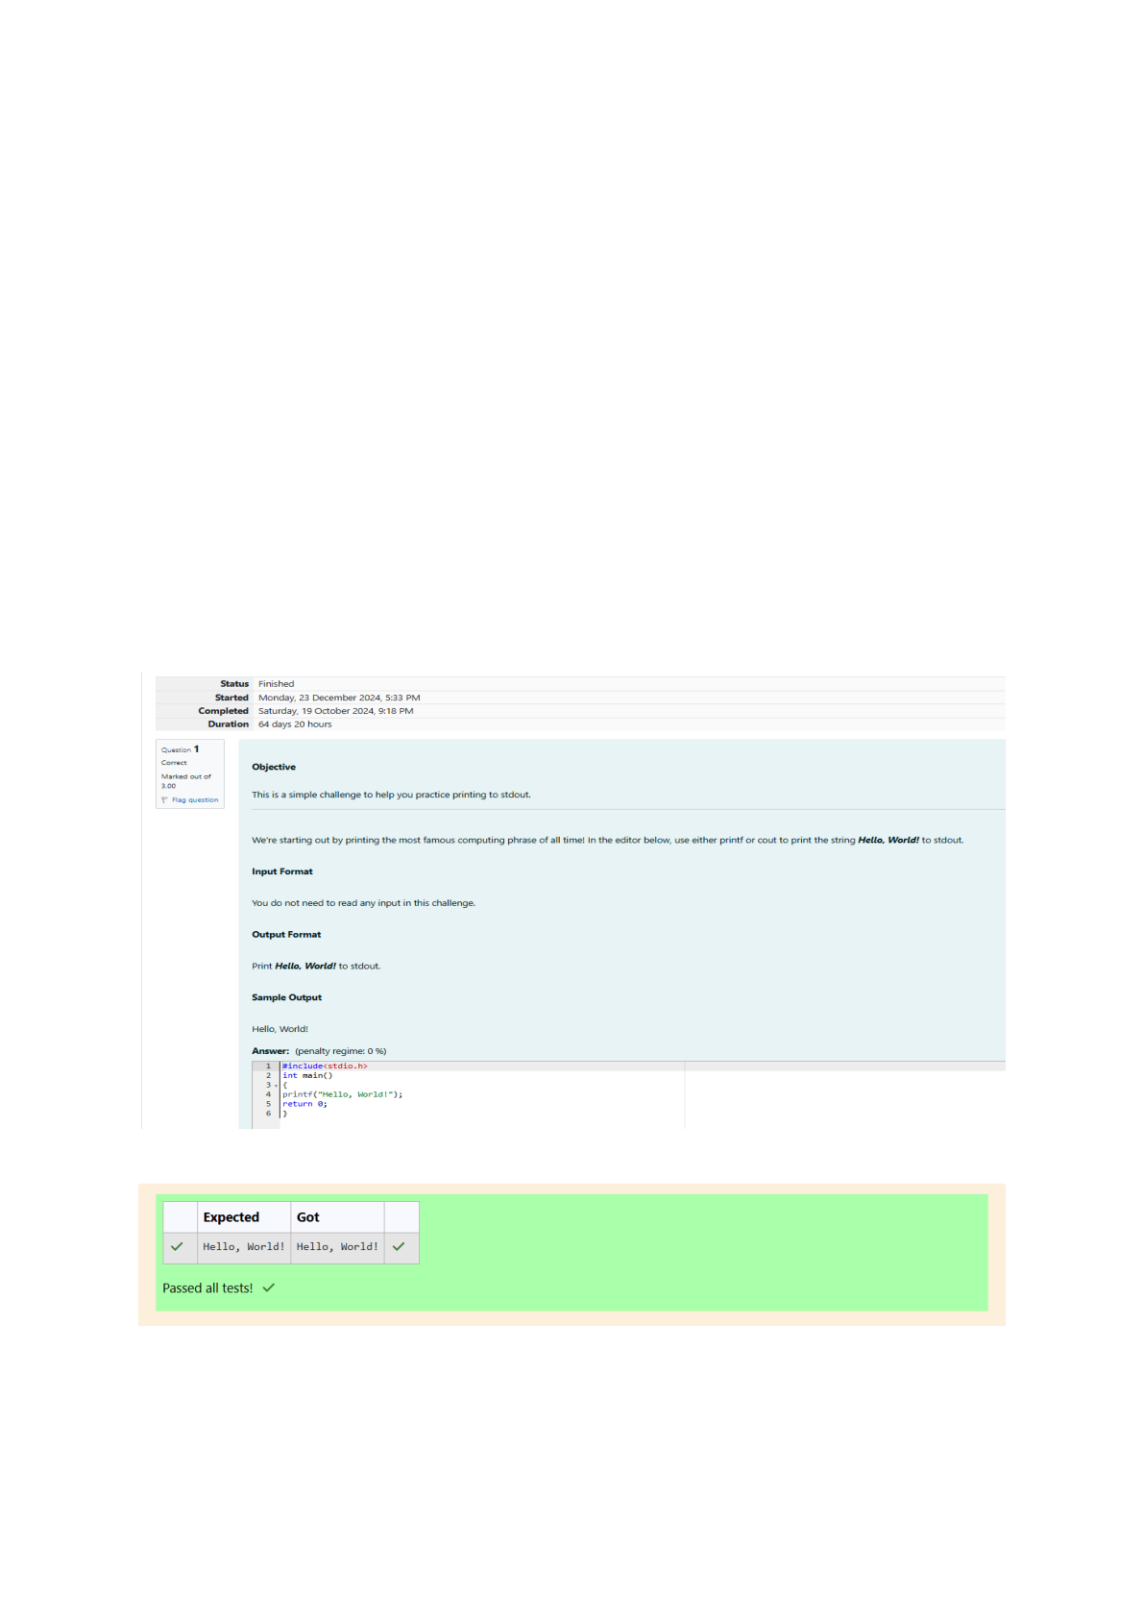

Week : 01-01

Q1) Problem Statement:

This is a simple challenge to help you practice printing to stdout. We're starting out by

printing the most famous computing phrase of all time! In the editor below, use either printf

or cout to print the string Hello, World! to stdout.

Input Format

You do not need to read any input in this challenge.

Output Format

Print Hello, World! to stdout.

Sample Output 1

Hello, World!

OUTPUT:

Q2) This challenge will help you to learn how to take a character, a string and a sentence as input in

C. To take a single character ch as input, you can use scanf("%c", &ch); and printf("%c", ch) writes a

character specified by the argument char to stdout:

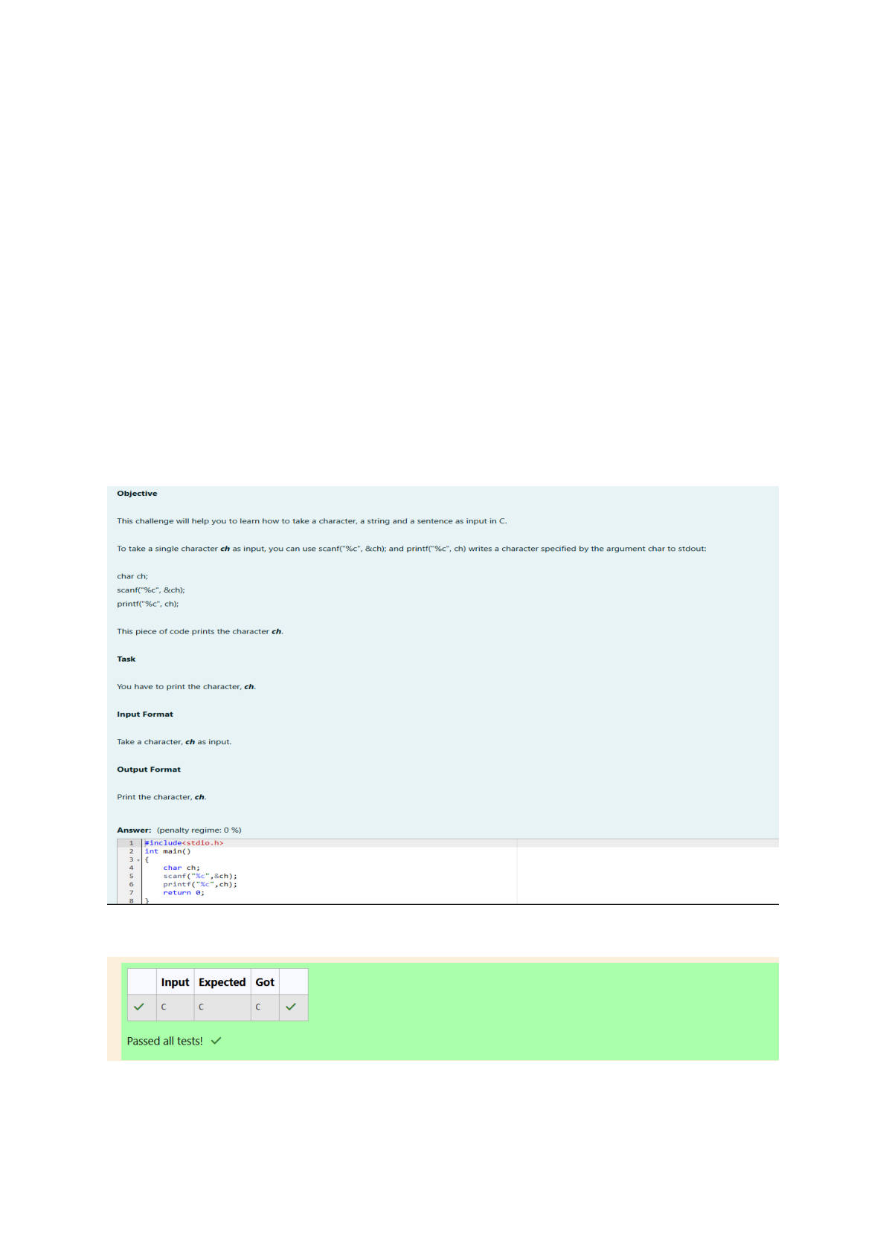

char ch;

scanf("%c", &ch);

printf("%c", ch);

Sample Input 1

C

program

Programming using C

Sample Output 1

C

program

Programming using C

OUTPUT:

Q3) Problem Statement:

The fundamental data types in c are int, float and char. Today, we're discussing int and float data

types.

The printf() function prints the given statement to the console. The syntax is printf("format string",

argument_list);. In the function, if we are using an integer, character, string or float as argument,

then in the format string we have to write %d (integer), %c (character), %s (string), %f (float)

respectively.

The scanf() function reads the input data from the console. The syntax is scanf("format string",

argument_list);. For ex: The scanf("%d", &number) statement reads integer number from the

console and stores the given value in variable number.To input two integers separated by a space on

a single line, the command is scanf("%d %d", &n, &m), where n and m are the two integers.

Task

Your task is to take two numbers of int data type, two numbers of float data type as input and

output their sum:

Declare 4 variables: two of type int and two of type float.

Read 2 lines of input from stdin (according to the sequence given in the 'Input Format' section

below) and initialize your 4 variables.

Use the + and - operator to perform the following operations:

Print the sum and difference of two int variable on a new line.

Print the sum and difference of two float variable rounded to one decimal place on a new line.

Input Format

The first line contains two integers.

The second line contains two floating point numbers.

Constraints: 1 ≤ integer variables ≤ 10^4

1 ≤ float variables ≤ 10^4

Output Format

Print the sum and difference of both integers separated by a space on the first line, and the sum and

difference of both float (scaled to 1 decimal place) separated by a space on the second line.

Sample Input

10 4

4.0 2.0

Sample Output

14 6

6.0 2.0

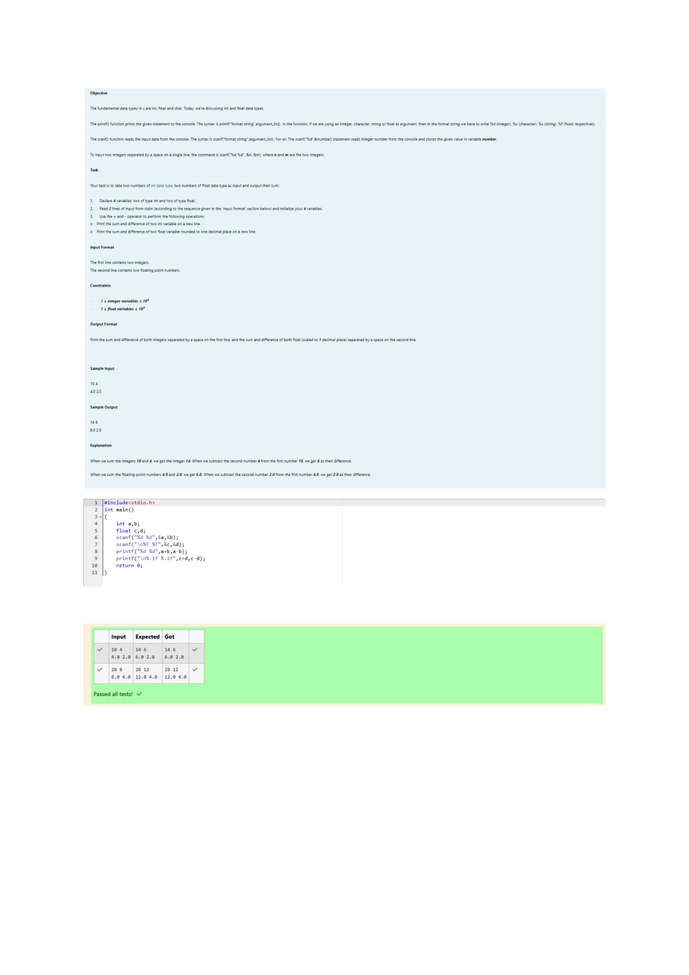

OUTPUT:

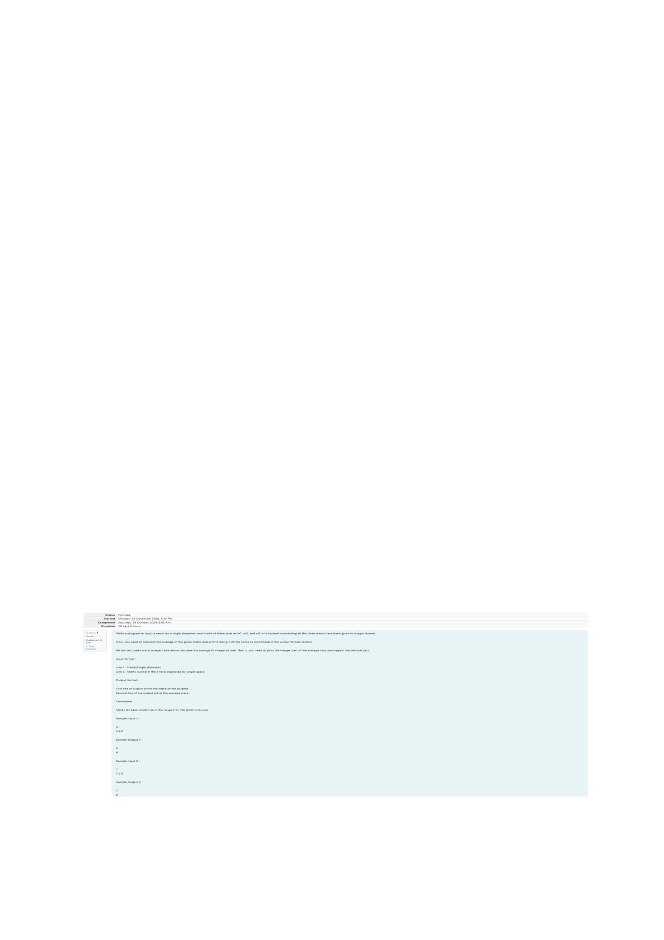

Week:01-02

Q1) Problem Statement

Write a program to input a name (as a single character) and marks of three tests as m1, m2, and m3

of a student considering all the three marks have been given in integer format.

Now, you need to calculate the average of the given marks and print it along with the name as

mentioned in the output format section.

All the test marks are in integers and hence calculate the average in integer as well. That is, you need

to print the integer part of the average only and neglect the decimal part.

Input Format:

Line 1: Name (Single character)

Line 2: Marks scored in the 3 tests separated by single space.

Output Format:

First line of output prints the name of the student. Second line of the output prints the average

mark.

Constraints

Marks for each student lie in the range 0 to 100 (both inclusive)

Sample Input 1:

A

3 4 6

Sample Output 1:

A

4

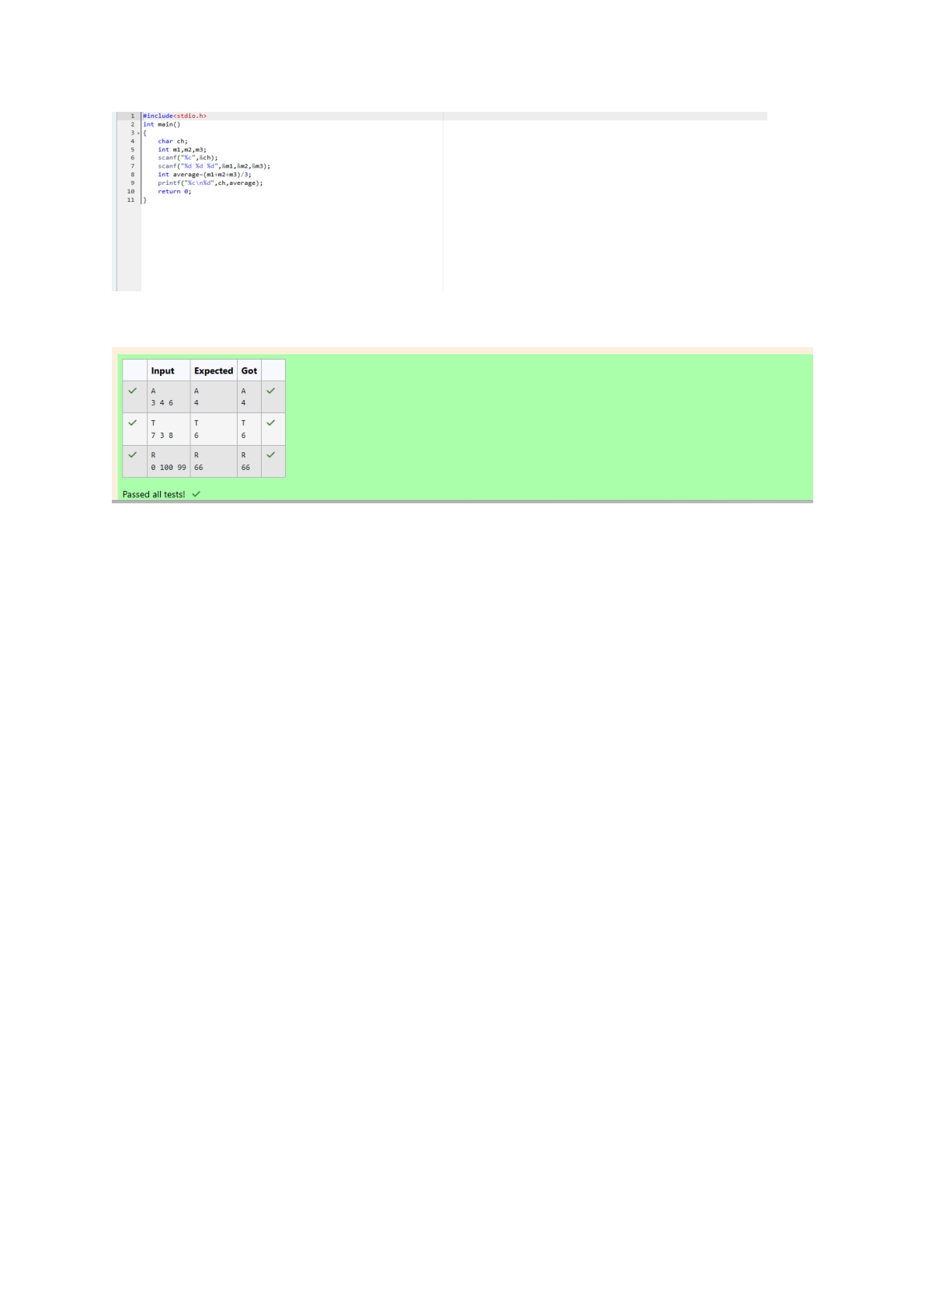

OUTPUT:

Q2) Problem Statement:

Some C data types, their format specifiers, and their most common bit widths are as follows:

Int ("%d"): 32 Bit integer

Long ("%ld"): 64 bit integer

Char ("%c"): Character type

Float ("%f"): 32 bit real value

Double ("%lf"): 64 bit real value

Reading

To read a data type, use the following syntax:

scanf("format_specifier", &val)

For example, to read a character followed by a double:

C

char ch;

double d;

scanf("%c %lf", &ch, &d);

For the moment, we can ignore the spacing between format specifiers.

Printing

To print a data type, use the following syntax:

printf("format_specifier", val)

For example, to print a character followed by a double:

C

char ch = 'd';

double d = 234.432;

printf("%c %lf", ch, d);

Note: You can also use cin and cout instead of scanf and printf; however, if you are taking a million

numbers as input and printing a million lines, it is faster to use scanf and printf.

Input Format

Input consists of the following space-separated values: int, long, char, float, and double,

respectively.

Output Format

Print each element on a new line in the same order it was received as input. Note that the floating-

point value should be correct up to 3 decimal places and the double to 9 decimal places.

Sample Input

3

12345678912345

a

334.23

14049.30493

Sample Output

3

12345678912345

a

334.230

14049.304930000

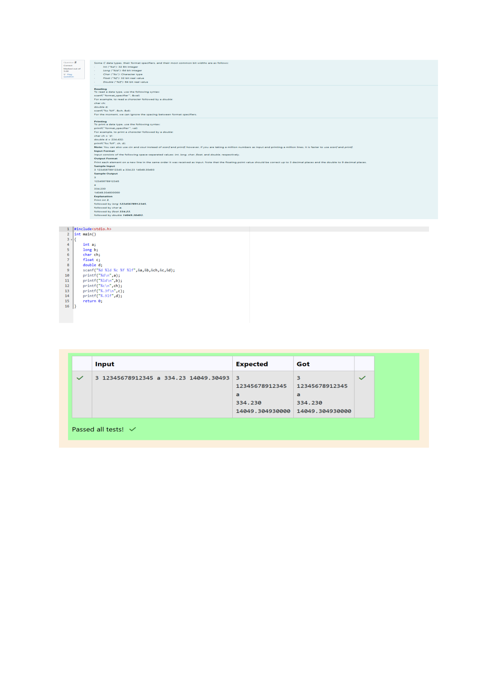

OUTPUT:

Q3) Problem Statement:

Write a program to print the ASCII value and the two adjacent characters of the given character.

Input Format: Reads the character

Output Format: First line prints the ascii value, second line prints the previous character and next

character of the input character

Sample Input 1:

E

Sample Output 1:

69

DF

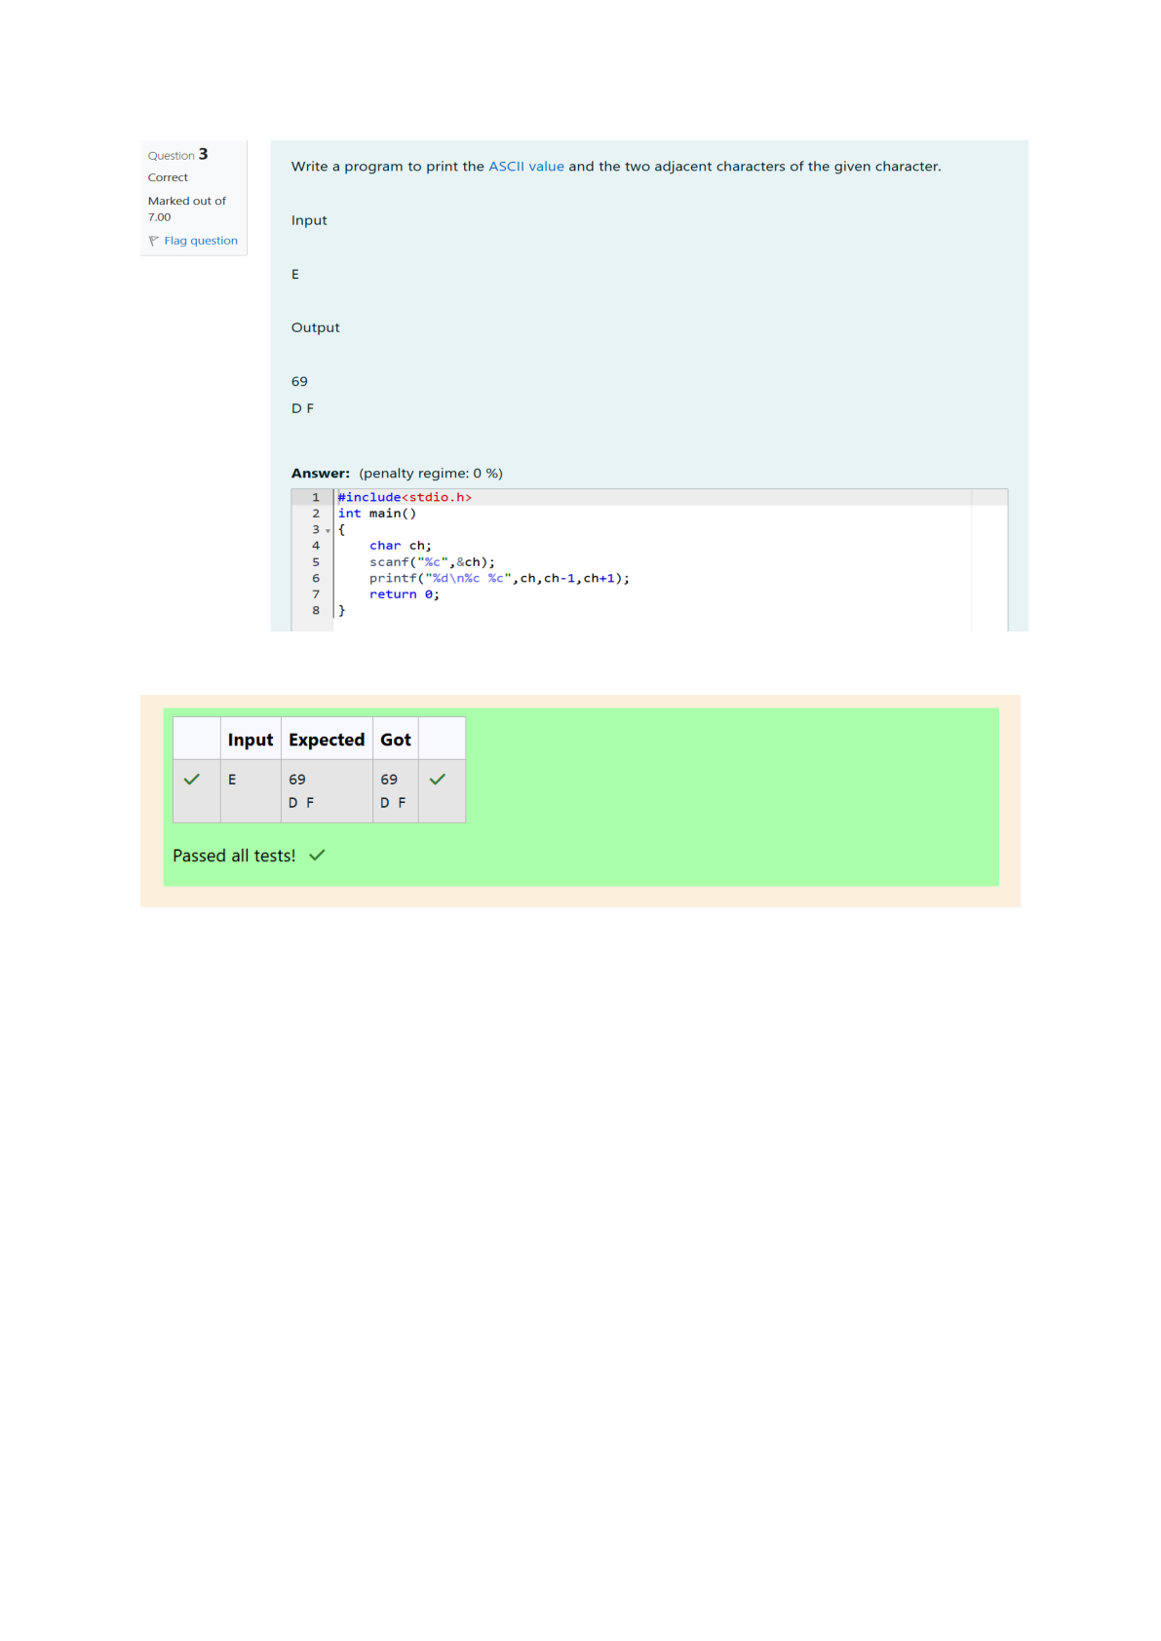

OUTPUT: